## Curtin University – Department of Computing

## **Assignment Cover Sheet / Declaration of Originality**

## Complete this form if/as directed by your unit coordinator, lecturer or the assignment specification.

| Last name: | Bevacqua | Student ID: | 20162896 | |
| --- | --- | --- | --- | --- |
| Other name(s): | Austin | | | |
| Unit name: | Capstone Computing Project 1 | Unit ID: | ISAD3000 | |
| Lecturer / unit coordinator: | Senjian An | Tutor: |  | |
| Date of submission: | 15/04/2022 | Which assignment? | Milestone 3 | (Leave blank if the unit has only one assignment.) |

## I declare that:

## · The above information is complete and accurate.

## · The work I am submitting is *entirely my own*, except where clearly indicated otherwise and correctly referenced.

## · I have taken (and will continue to take) all reasonable steps to ensure my work is *not accessible* to any other students who may gain unfair advantage from it.

## · I have *not previously submitted* this work for any other unit, whether at Curtin University or elsewhere, or for prior attempts at this unit, except where clearly indicated otherwise.

## I understand that:

## · Plagiarism and collusion are dishonest, and unfair to all other students.

## · Detection of plagiarism and collusion may be done manually or by using tools (such as Turnitin).

## · If I plagiarise or collude, I risk failing the unit with a grade of ANN (“Result Annulled due to Academic Misconduct”), which will remain permanently on my academic record. I also risk termination from my course and other penalties.

## · Even with correct referencing, my submission will only be marked according to what I have done myself, specifically for this assessment. I cannot re-use the work of others, or my own previously submitted work, in order to fulfil the assessment requirements.

## · It is my responsibility to ensure that my submission is complete, correct and not corrupted.

| Signature: | AUSTIN BEVACQUA | Date ofsignature: | 15/04/2022 |
| --- | --- | --- | --- |

## 

*ISAD3000 Capstone Computing Project Milestone 3 Individual Report*

***Austin Bevacqua***

***Group E8: Amristar Industry Project [Virtual Jukebox]***

Group Members:

Austin Bevacqua, Bradley van der Zwan, Dillon Vincent,   
Ryan Webster, Tanaka Chitete

## 

## 

## 

## 

## Progress Tracking

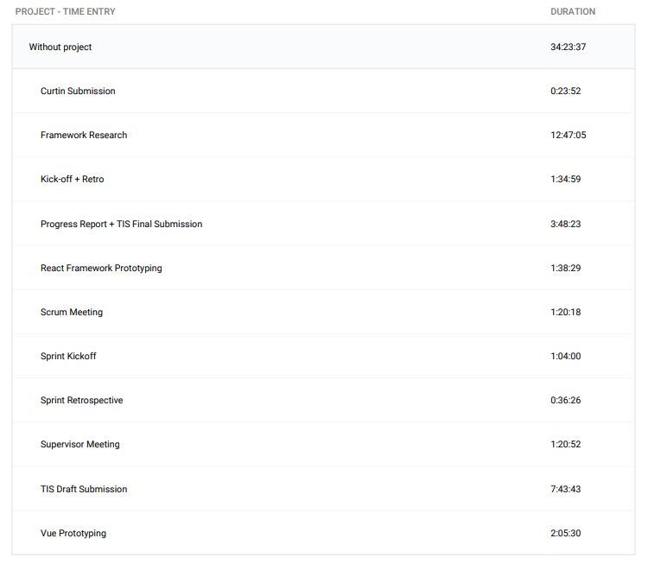

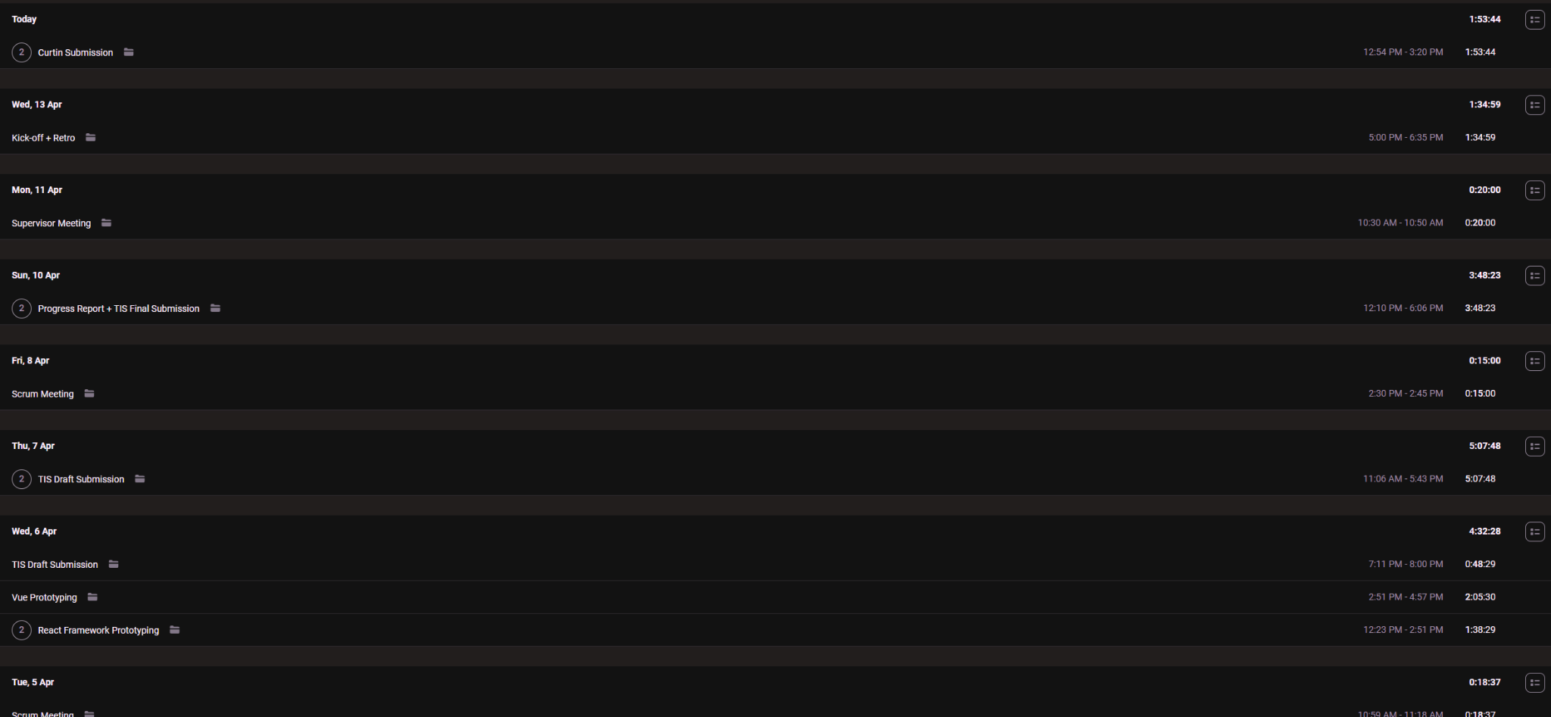

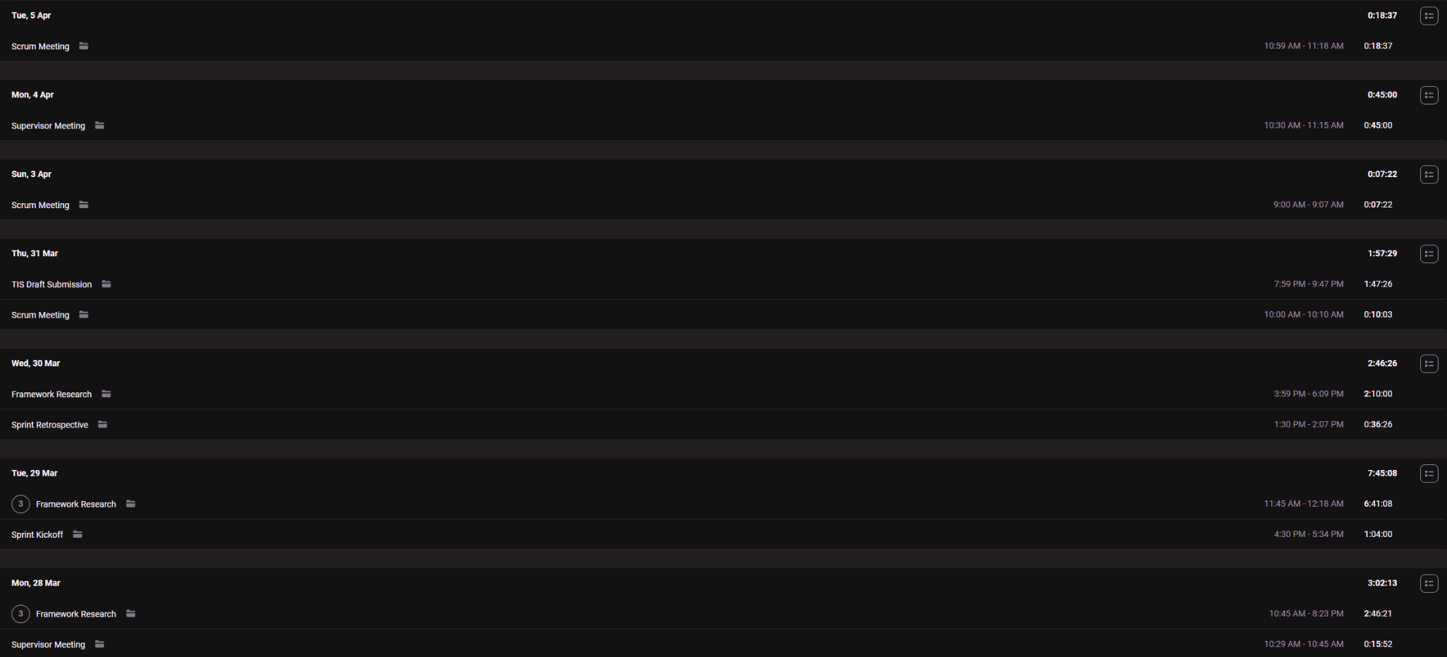

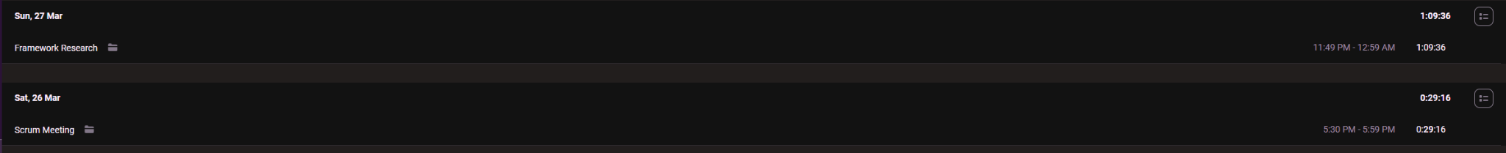

**Supervisor Meetings (28th March, 4th April, 11th April)**

Took part in supervisor meetings with Amristar. Discussed was the ongoing progress of the TIS, and the upcoming submission of the SRS

Minutes taken by Bradley

<https://drive.google.com/drive/folders/1rKsgHWpck5Wpd935lpXTCyADSaPFoQgS?usp=sharing>

**Sprint Kickoffs (29th March, 13 April)**

Sprint kickoffs were run and organised by myself. As our sprints are two weeks long, we discussed what we would be doing the next two weeks, and put these goals into tickets. We then did story point allocation, and assigned these tickets to a person.

Minutes for these meetings were written down by Bradley, who has included these documents in the group report.

<https://drive.google.com/drive/folders/1OImhOwUw_PIgKJ7r6JA-oma24w2zfaJa?usp=sharing>

**Sprint Retrospectives (30th March, 13th April)**

Sprint retrospectives were run and organised by myself. As our sprints are two weeks long, we reflected on how the last 2 weeks had gone, and came up with action items to improve on the next sprint. Retrospective meetings were run by having group members write down what they thought went well, and what could be improved on for the sprint. Every group member was then given 3 votes, and we discussed the highest voted cards.

Minutes for these meetings were written down by Bradley, who has included these documents in the group report.

<https://drive.google.com/drive/folders/1OImhOwUw_PIgKJ7r6JA-oma24w2zfaJa?usp=sharing>

**Scrum Meetings (26th March, 31st March, 3rd April, 5th April, 8th April)**

Scrum meetings were run and organised by myself. Each meeting consists of the following questions:

* What have you been doing?
* What are you currently doing?
* What will you be doing?
* Are you having problems with anything?

Answers to these questions were written down by Bradley, who has included these documents in this report. We also used the scrum meeting times to discuss submissions, meetings with supervisors and when the next meeting would take place.

<https://drive.google.com/drive/folders/1OImhOwUw_PIgKJ7r6JA-oma24w2zfaJa?usp=sharing>

**Framework Research (27th March - 30th March)**

I continued my work researching frontend and backend frameworks. A significant amount of time was spent this sprint to create a detailed comparison between the top candidates for frontend and backend frameworks, to ensure the submitted TIS would be high quality and the chosen technology stack would be as suitable as possible.

All my work was done on the cloud on Google slides, so all times I edited the document are visible.

Frontend Technology investigation <https://docs.google.com/presentation/d/1qGjtVOsfglGwDRRtJJ-COLKPchtvUG0RCZ7N68MP920/edit?usp=sharing>

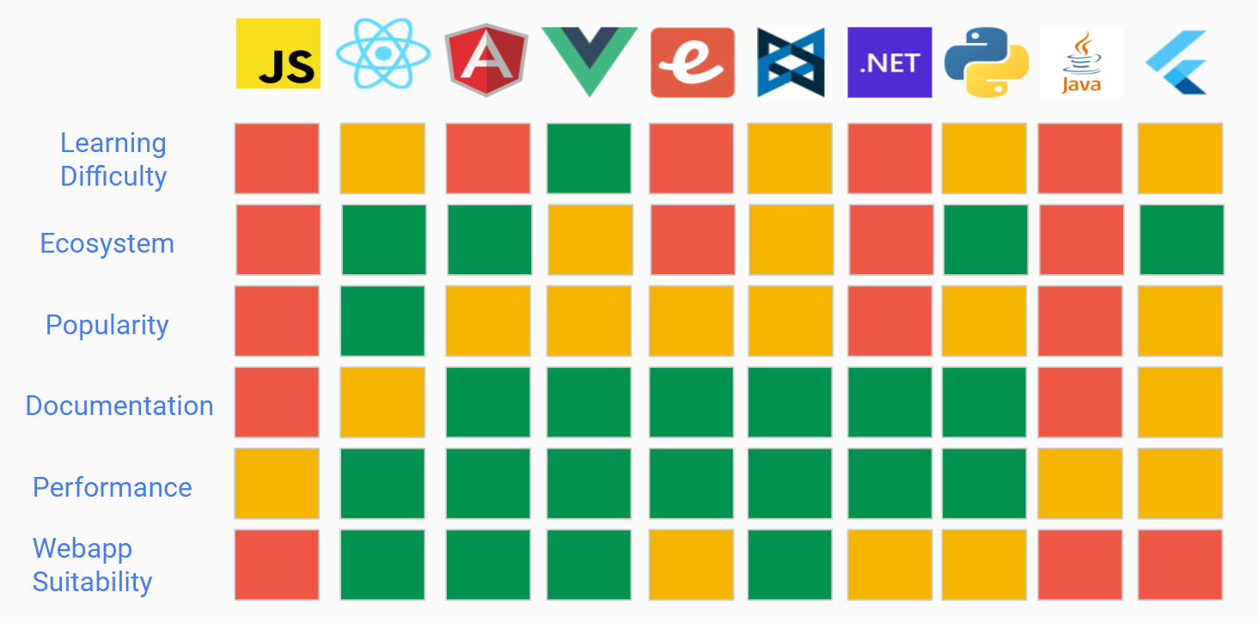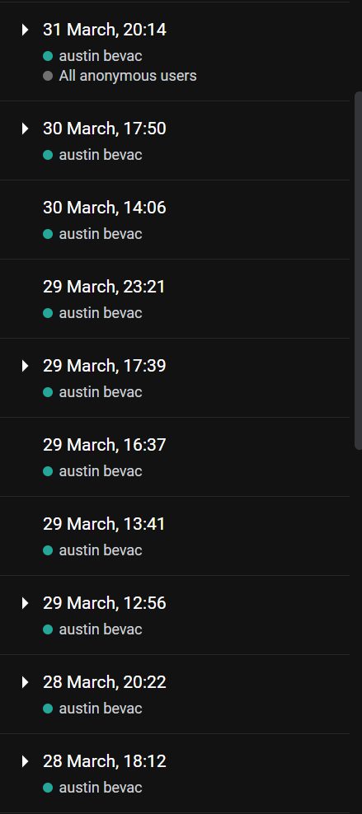

Backend Technology Investigation <https://docs.google.com/presentation/d/1V9lEM1aUGhMTJdL-NAEP3zJnzHv1uPppNCGQk29qTRM/edit?usp=sharing>

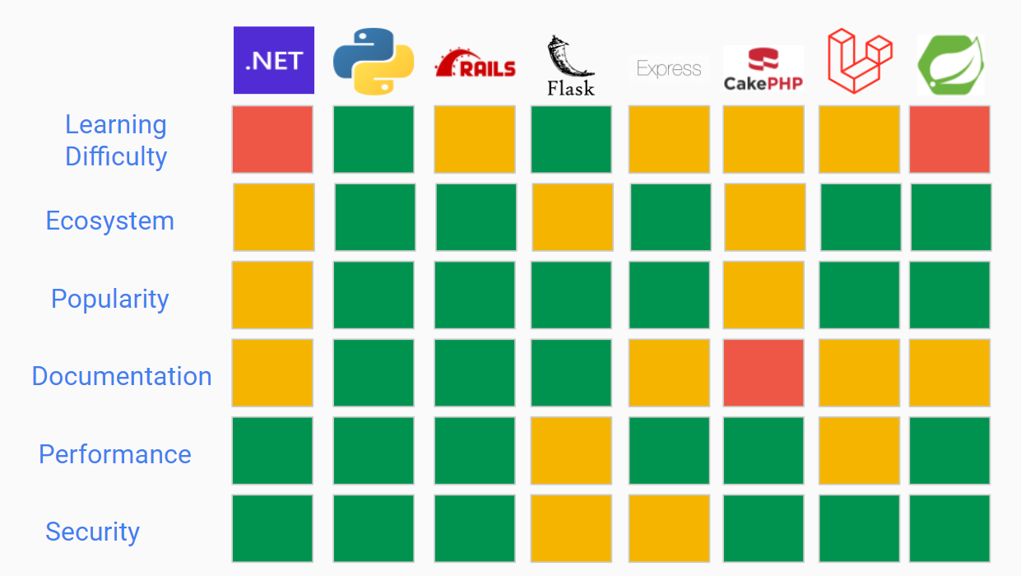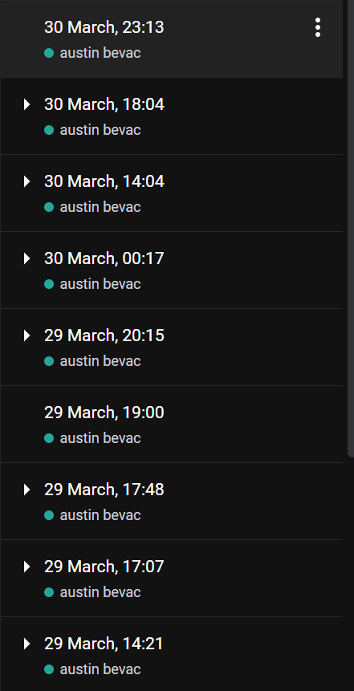

**TIS Drafts + Final Submission (31st March - 10th April)**

The main deliverable of this milestone was the submission of the TIS to Amristar. As a group, we created two drafts, which we then sent to Amristar for feedback, and a final submission. I was responsible for writing the frontend and backend sections of these documents, as well as helping out with document formatting, grammar and consistency.

The below link contains all 3 drafts, which showcase the edit history of all three documents.

<https://drive.google.com/drive/folders/1HRwxF2hvAp7NuhtgTB_6Otp_VpU6UqQa>

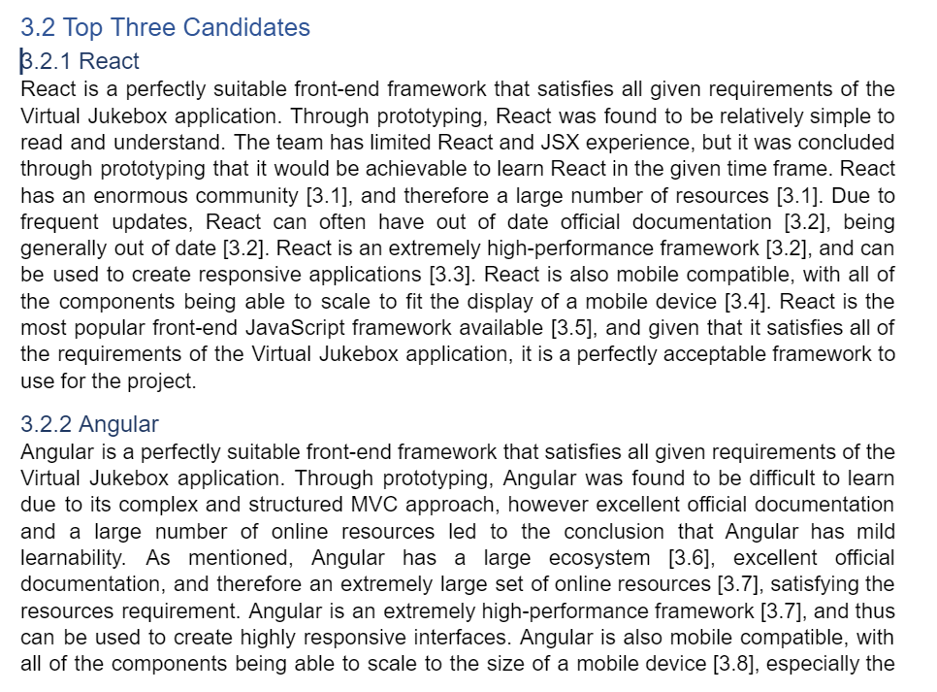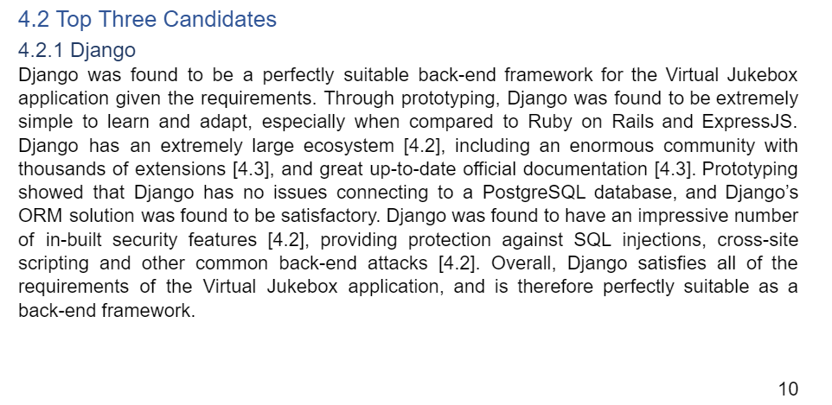

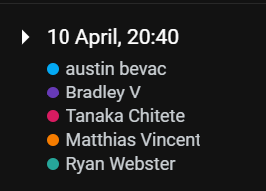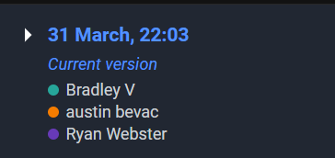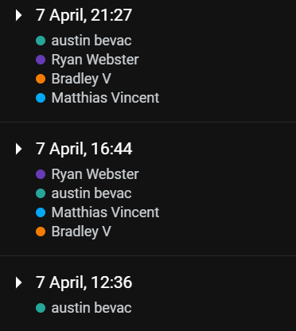

**Vue + React Prototyping (6th April)**

As part of our TIS, Amristar instructed us to conduct basic prototyping so that we could ensure all the elements of our technology stack would be able to communicate with each other. We decided to prototype our top three frontend frameworks, and see which would be the best fit for what we needed. I was in charge of Vue and React prototyping, while Dillon conducted Angular prototyping.

React prototype:

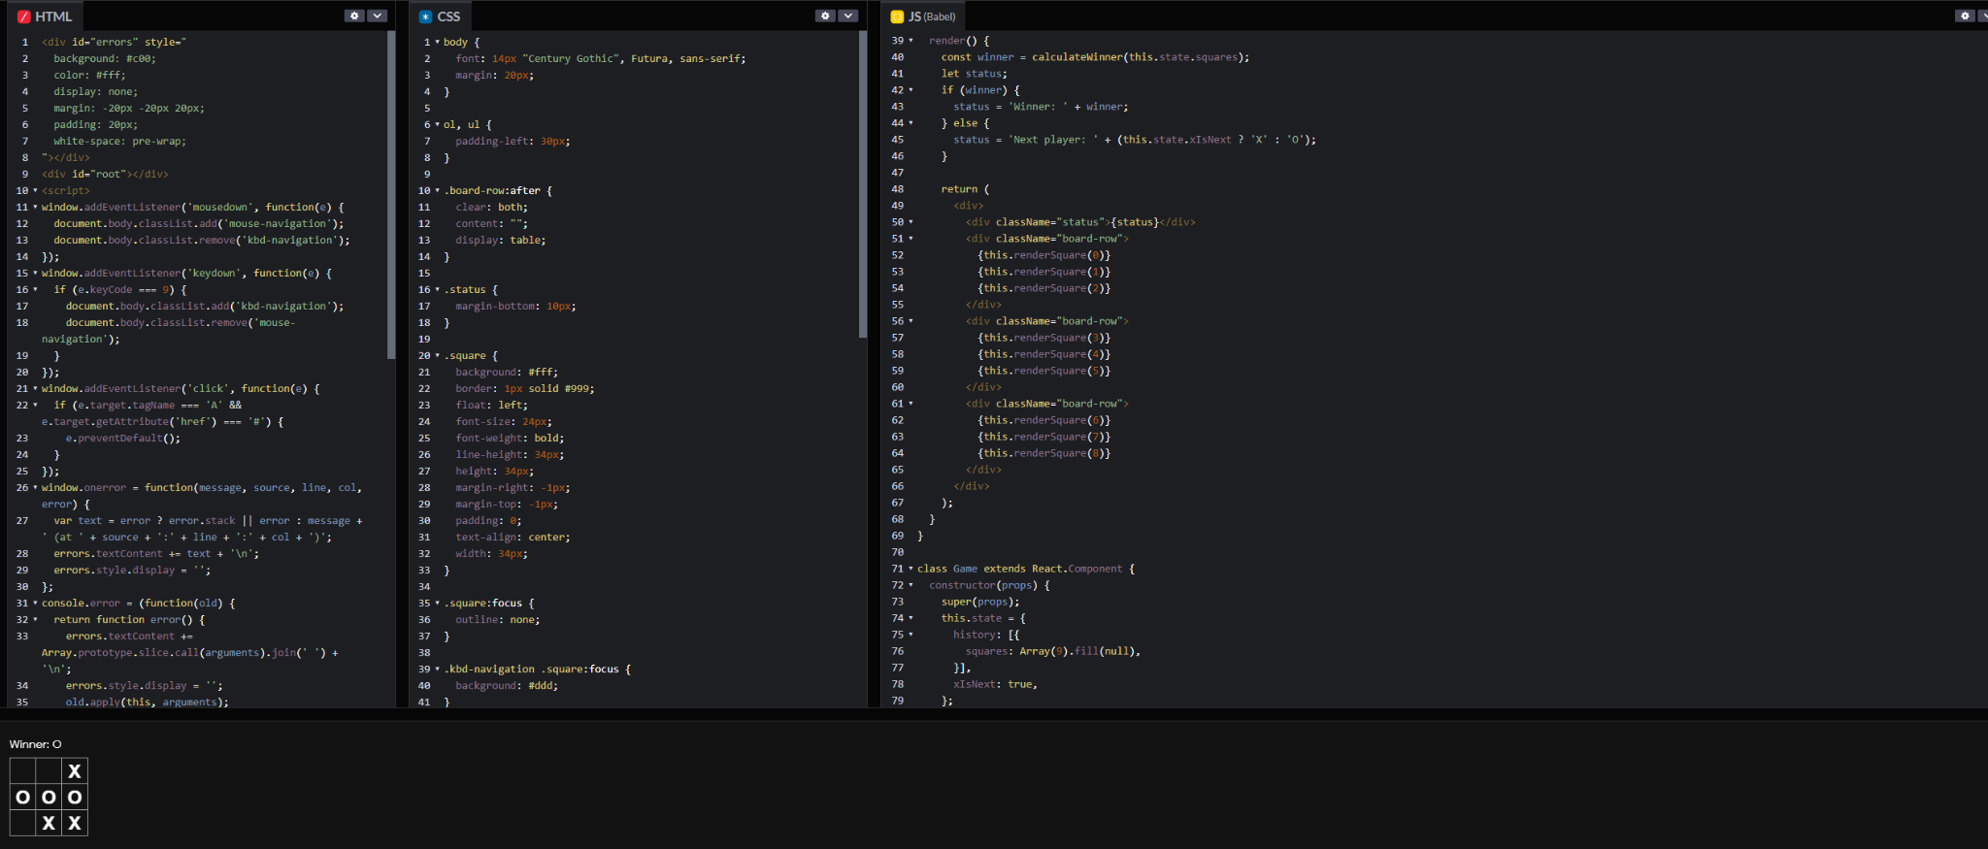

Vue prototype:

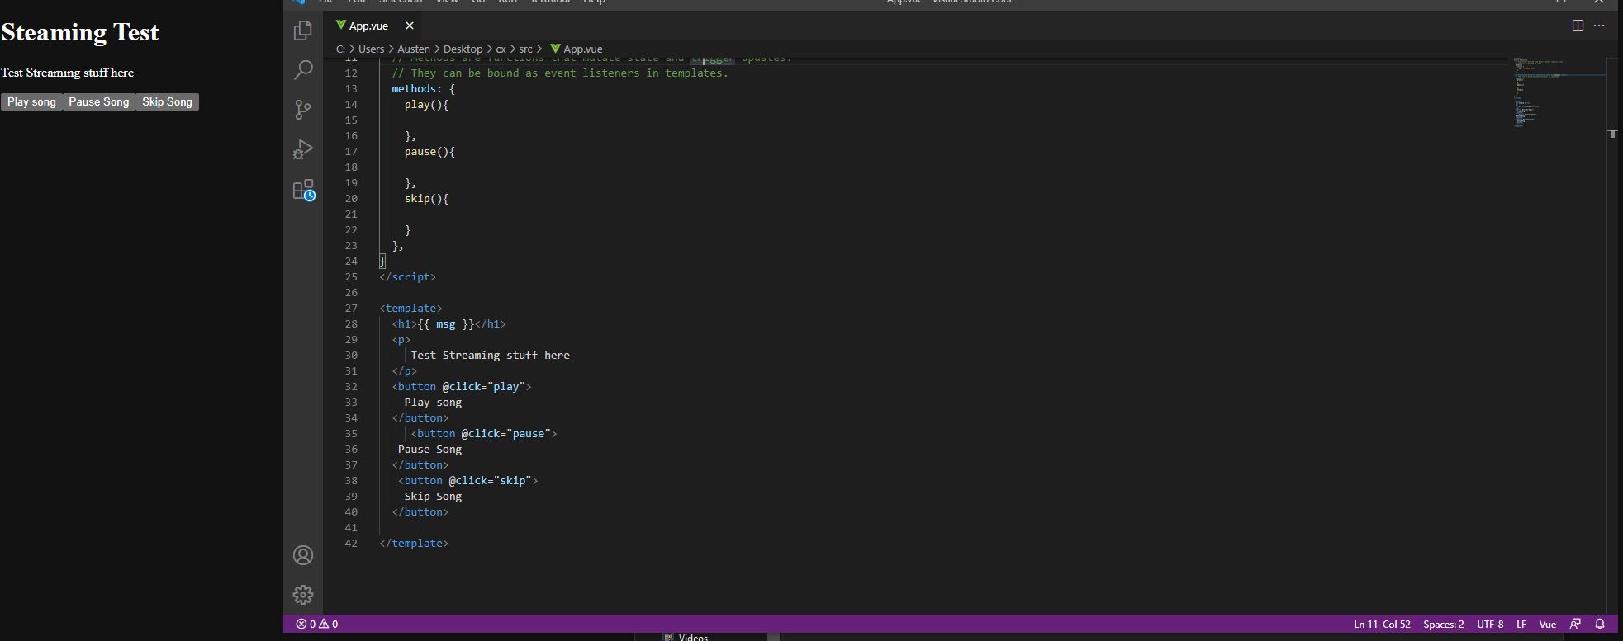

**Progress Report (10th April)**

In addition to the TIS, our group also had to submit a progress report detailing all of our group and individual work over the milestone period. I added my individual work to this document, which can be seen in the edit history.

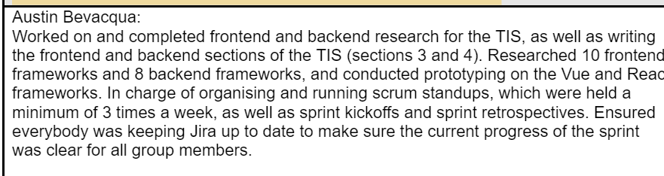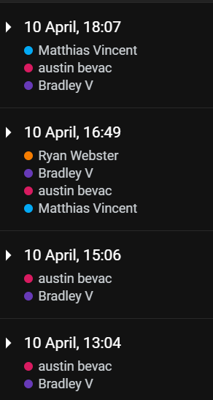

<https://docs.google.com/document/d/187tx1zImEPlwIYuKR-YXoqFMFNzjK-Bo/edit?rtpof=true>

**Curtin Milestone Submission (15th April)**

This document + group report, where I added my work over the previous period.

## Summary

After completing the TIS, we have a clear idea about the chosen technology stack, and we are certain we have chosen the best technology for the project. Our group is communicating regularly and effectively, meeting at least every 2 days for a supervisor, standup, or submission meeting. Every group member has put in a significant amount of work, and we are all following the agile process effectively.

On sprint 2 (29-3-2022 - 12-4-2022) I put 30 hours of work in, which meant I had less time to spend on my other units. Despite this, I am on track to continue putting the required number of hours in, and will start to make progress on the SRS today.